

**University Workshop Series**

**Power Query**

**Hands-on Training Lab**

**Lester Sim**

Data & AI Specialist

**Lim Le Shin**

Business Applications Specialist



Content Page

Environment Set Up 3

Importing of Data 4

Importing a Single File 4

Transform and Shape Data (Rows) 4

Remove Rows and Promote / Demote Headers 4

Remove Duplicates 5

Transform and Shape Data (Columns) 6

Remove Empty 6

Replace Values 6

Split Columns (by Number of Characters) 7

Reshaping Data 8

Pivot 8

Unpivot 8

Aggregating and Filtering Data 9

Group Rows of Data 9

Importing from a Folder of Files 9

Merging Queries 11

Power Pivot: Loading to Data Model & Create Relationships 15

Power Pivot: Creating PivotTables from Data Model 16

References 17

# Environment Set Up

1. Download files from <https://github.com/lestersimjj/MSLearnPowerQuery>
2. Check your version of Excel. No installation required for Excel 2016 and Office 365. Power Query is integrated in those versions, no additional installation required. For Excel 2010 and 2013, you will need to install a free Power Query add-in (<https://www.microsoft.com/en-au/download/details.aspx?id=39379>).
3. Click the Data tab of the Ribbon and you should see the following screen

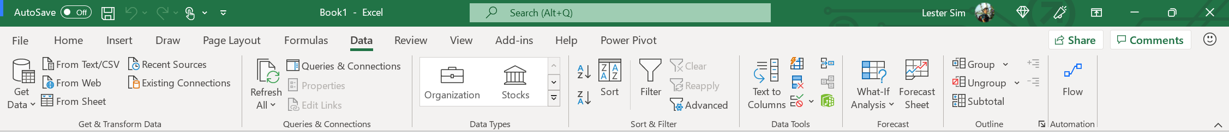

1. Otherwise, click File > Options > Customize Ribbon and ensure that the Data checkbox is checked

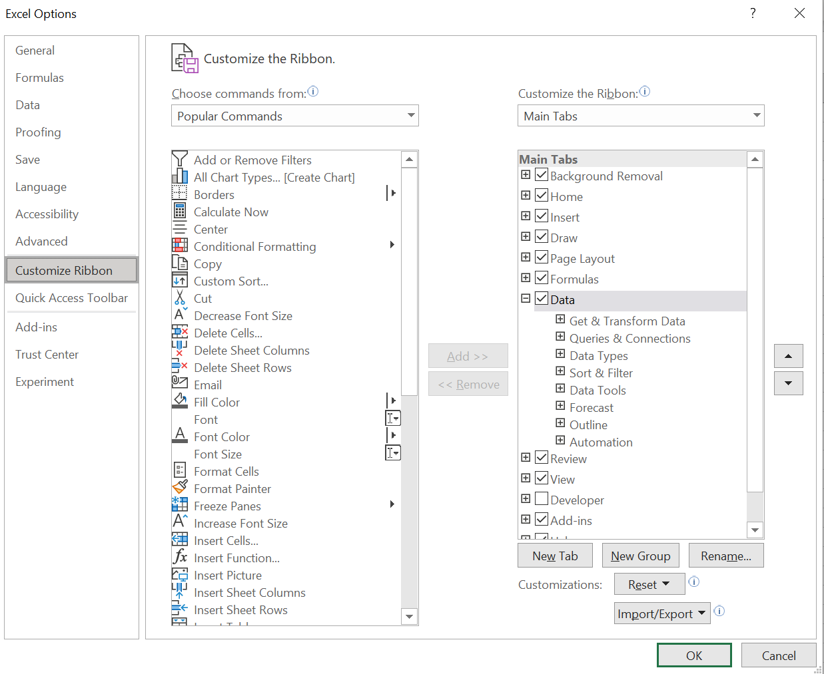

1. To enable the Power Pivot Ribbon, click **File** > **Options** > **Add-ins** > Click **Microsoft Power Pivot for Excel**
2. At the bottom of the window click **Manage** > **COM Add-ins** > **Go**

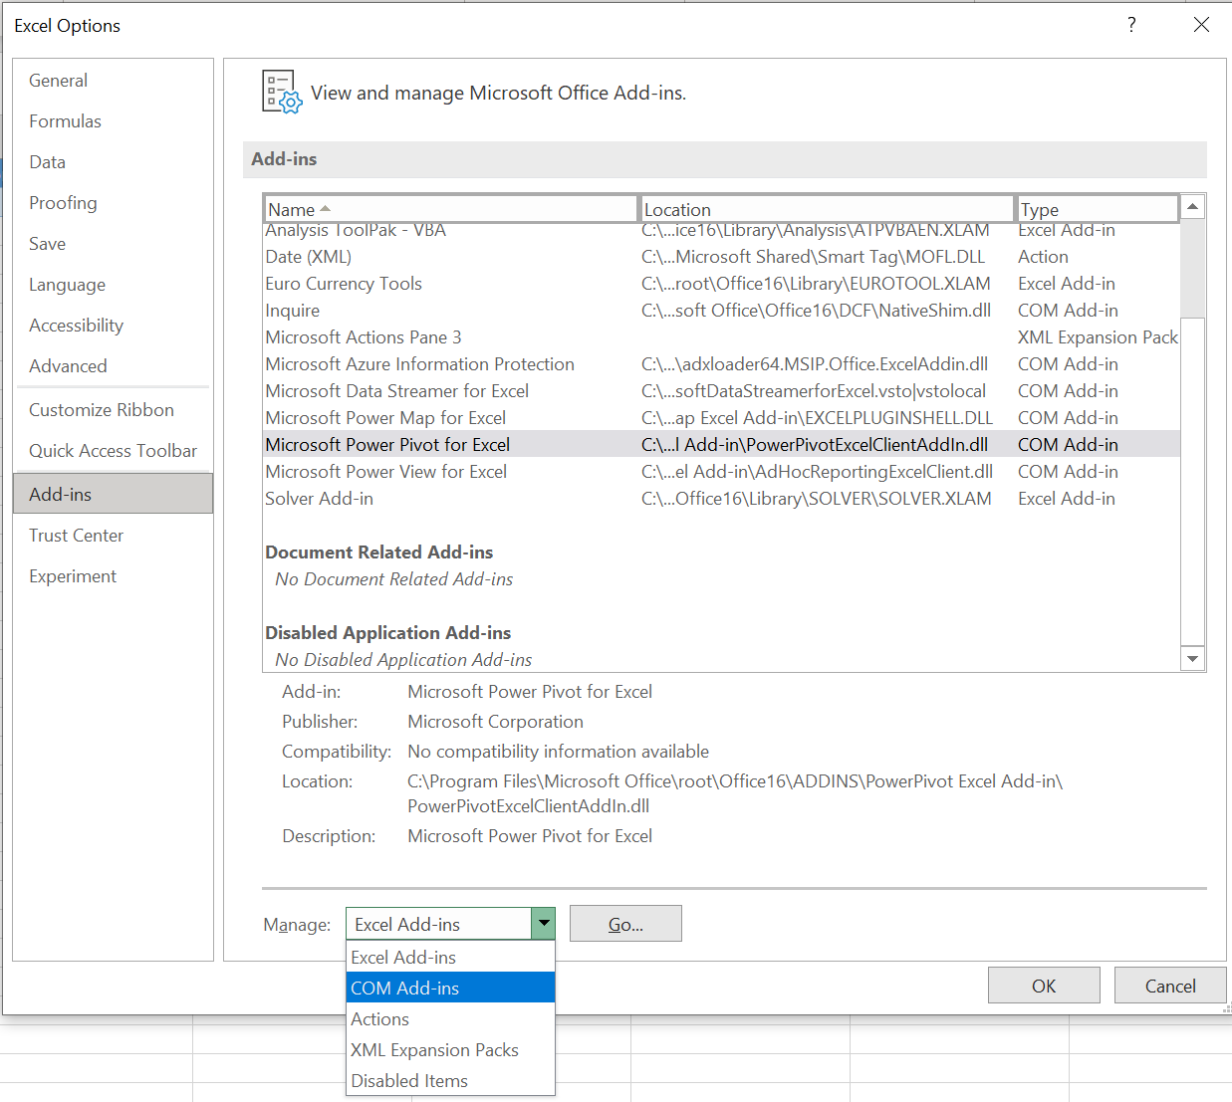

# Importing of Data

## Importing a Single File

1. Create a new spreadsheet.
2. Select **Data** > **Get Data** > **From File** > **From Workbook**. Open “Financial Sample Dataset.xlsx”.

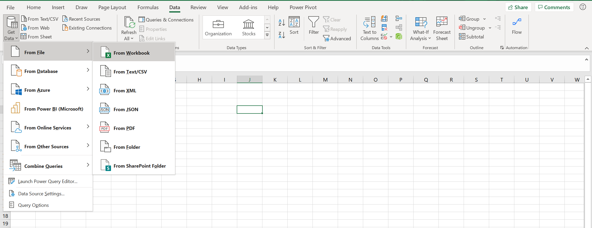

1. A prompt appears to select which table to load from the spreadsheet. Select **Sheet1** and click **Transform Data**.

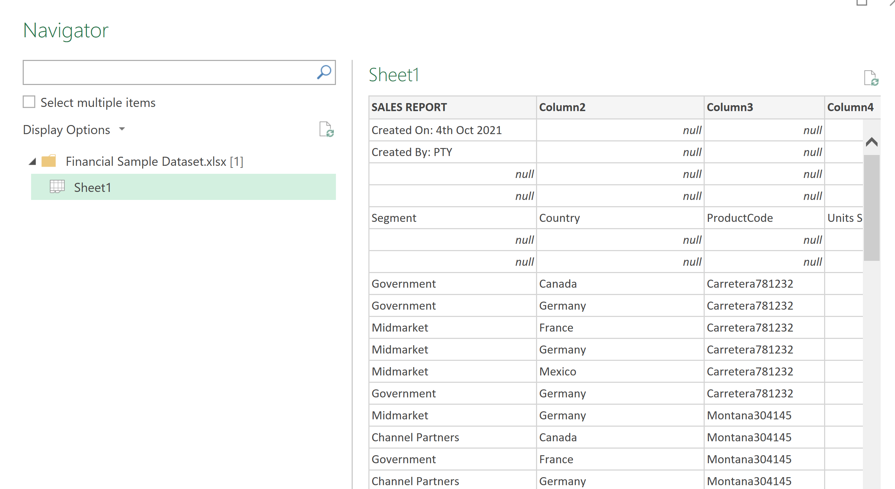

# Transform and Shape Data (Rows)

## Remove Rows and Promote / Demote Headers

1. On the Home tab, select Remove Rows > Remove Top Rows

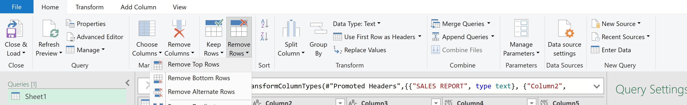

1. Specify to remove top 4 rows in the prompt

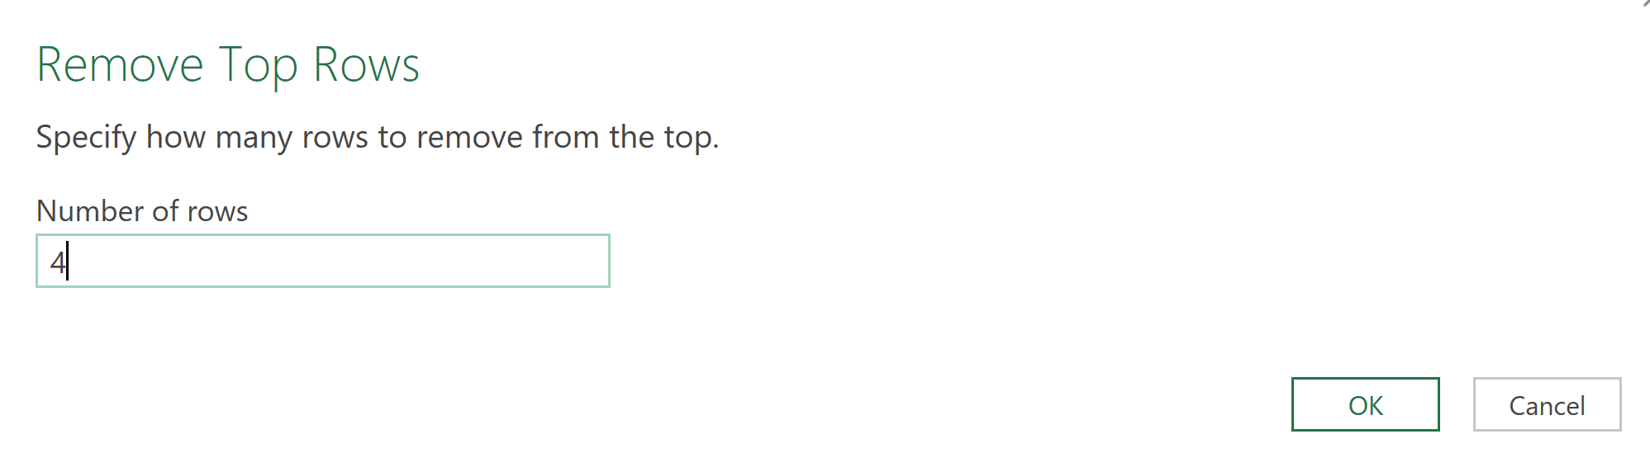

1. On the **Home** tab, in the **Transform** group. Select Use **First Rows as Headers**

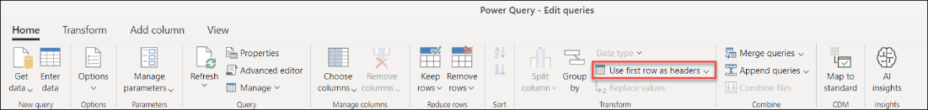

1. After you do the promote headers operation, your table will look like the following image.

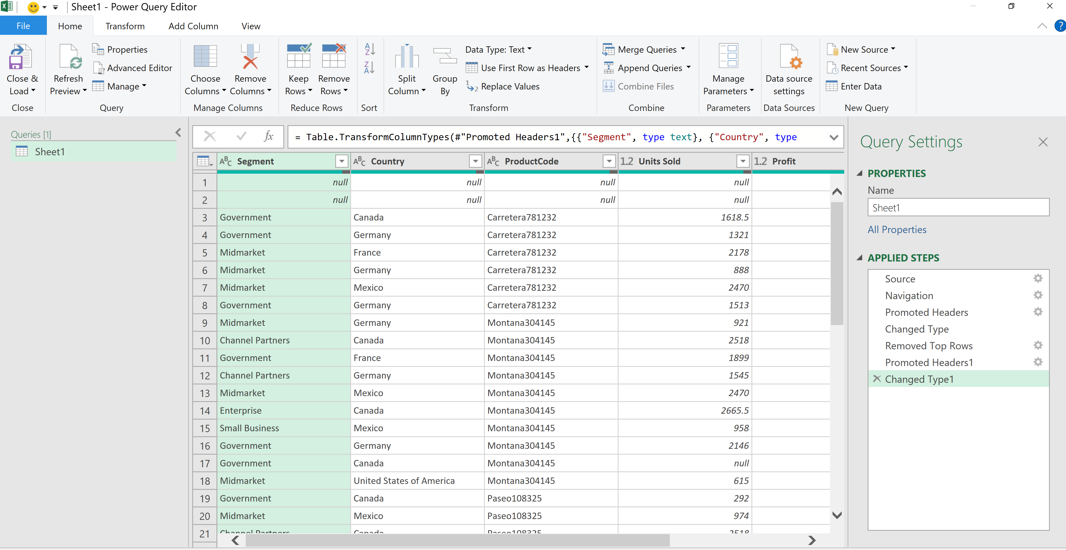

Note: To demote headers, repeat steps by replacing “Use First Rows as Headers” with “Use Headers as First Rows”.

## Remove Duplicates

1. Select the columns that contain duplicate values.
2. Go to the **Home** tab.
3. In the **Reduce rows** group, select **Remove rows**.
4. From the drop-down menu, select **Remove duplicates**.

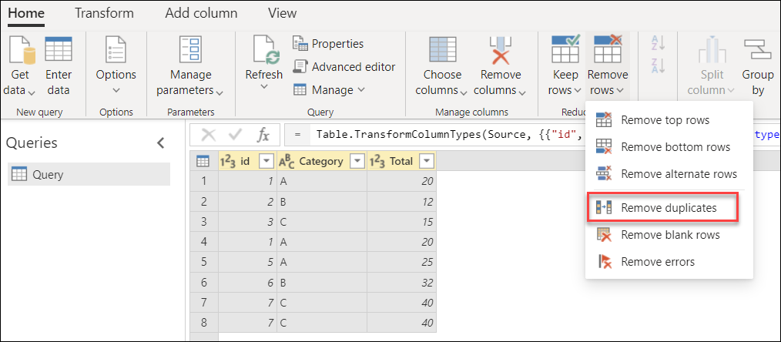

# Transform and Shape Data (Columns)

## Remove Empty

1. In the column header, you'll see an icon with an inverse triangle. When you select this icon, the sort and filter menu is displayed. With this menu, you can apply or remove any filters to or from your column.
2. Select **Segment** > **Remove empty** from the sort and filter menu, as shown in the following image.

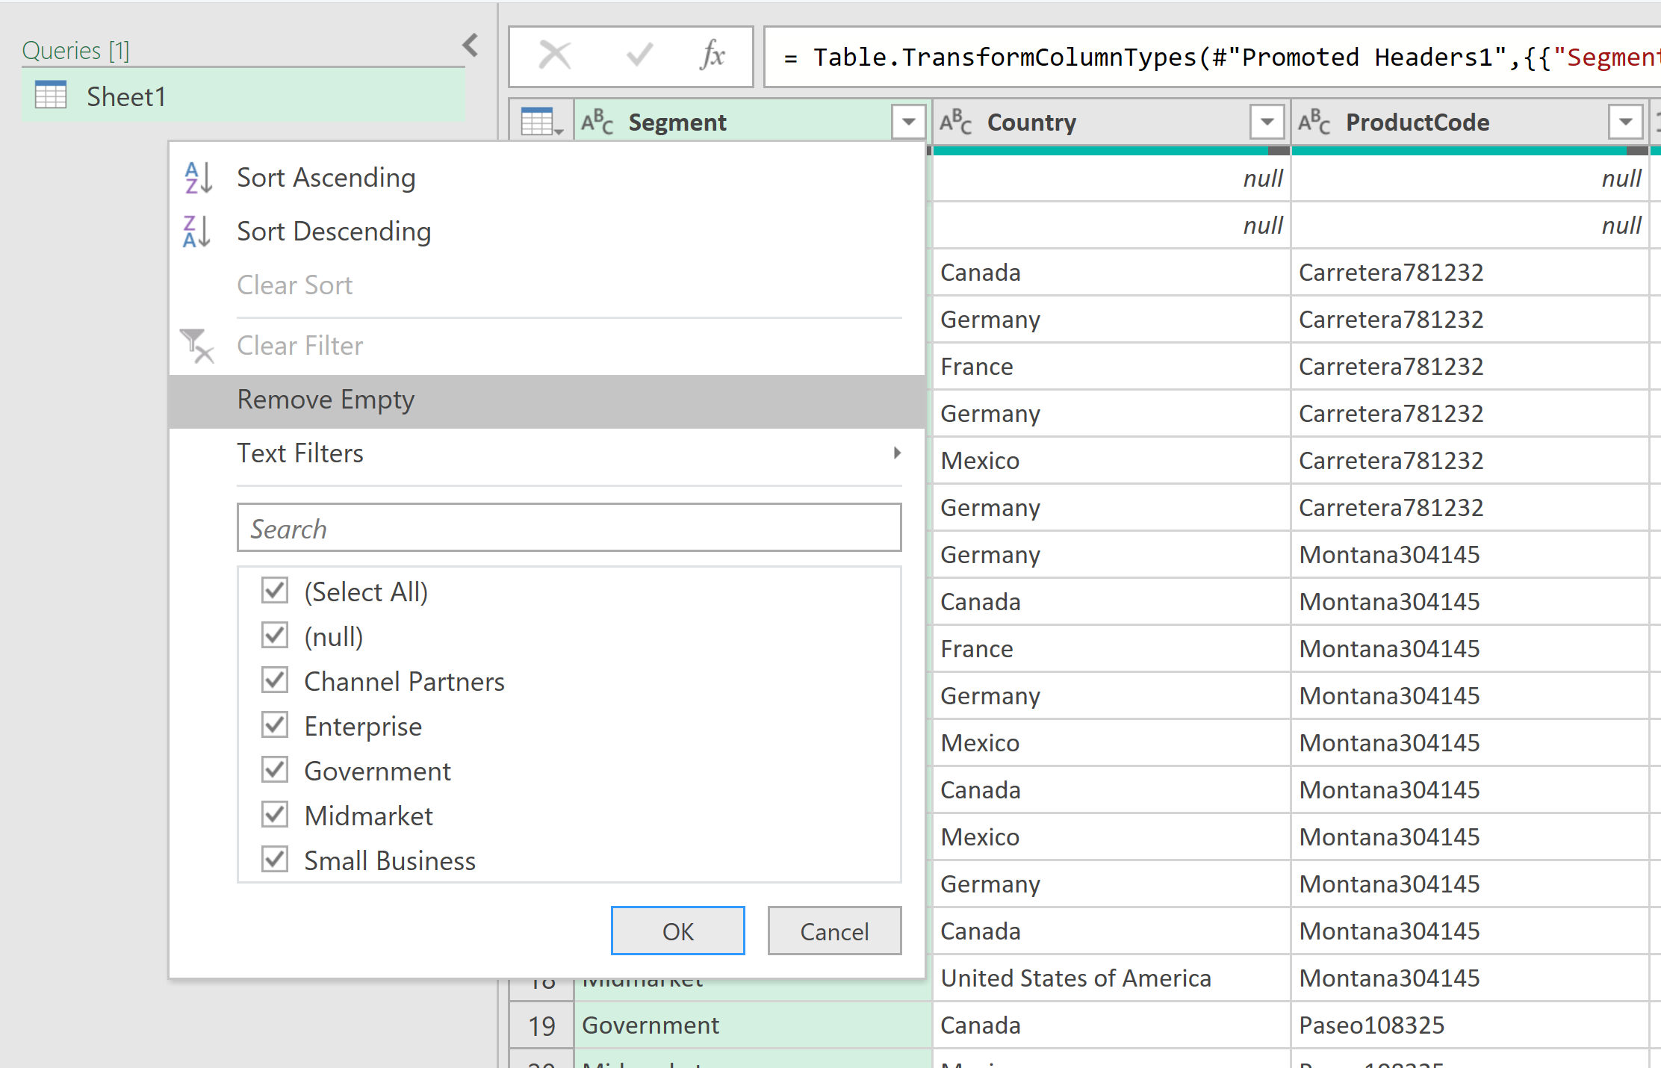

## Replace Values

1. Select the columns that contain values you wish to replace.
2. Go to the **Transform** tab, in the **Any column** group, select **Replace Values**.

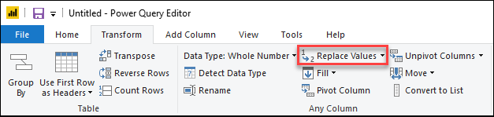

1. Insert the **Value to Find** and the value to **Replace With**, select **OK**.

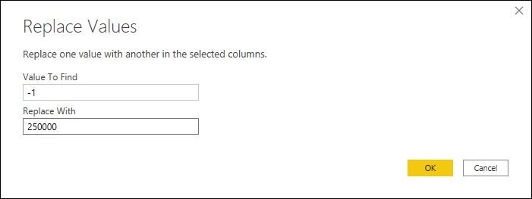

## Split Columns (by Number of Characters)

1. Select the **ProductCode** column > **Split Column** > **By Non-Digit to Digit**.

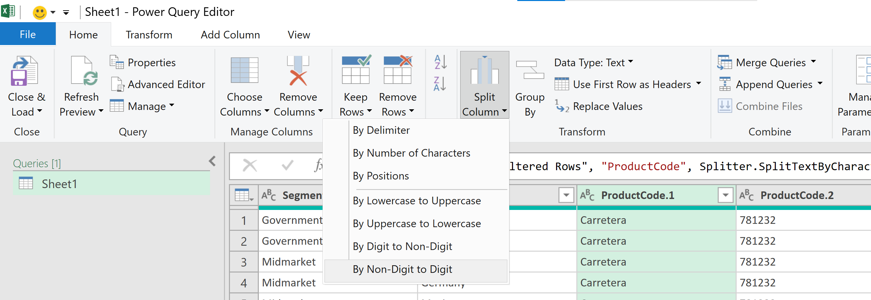

1. The result of that operation will give you a table with two columns.

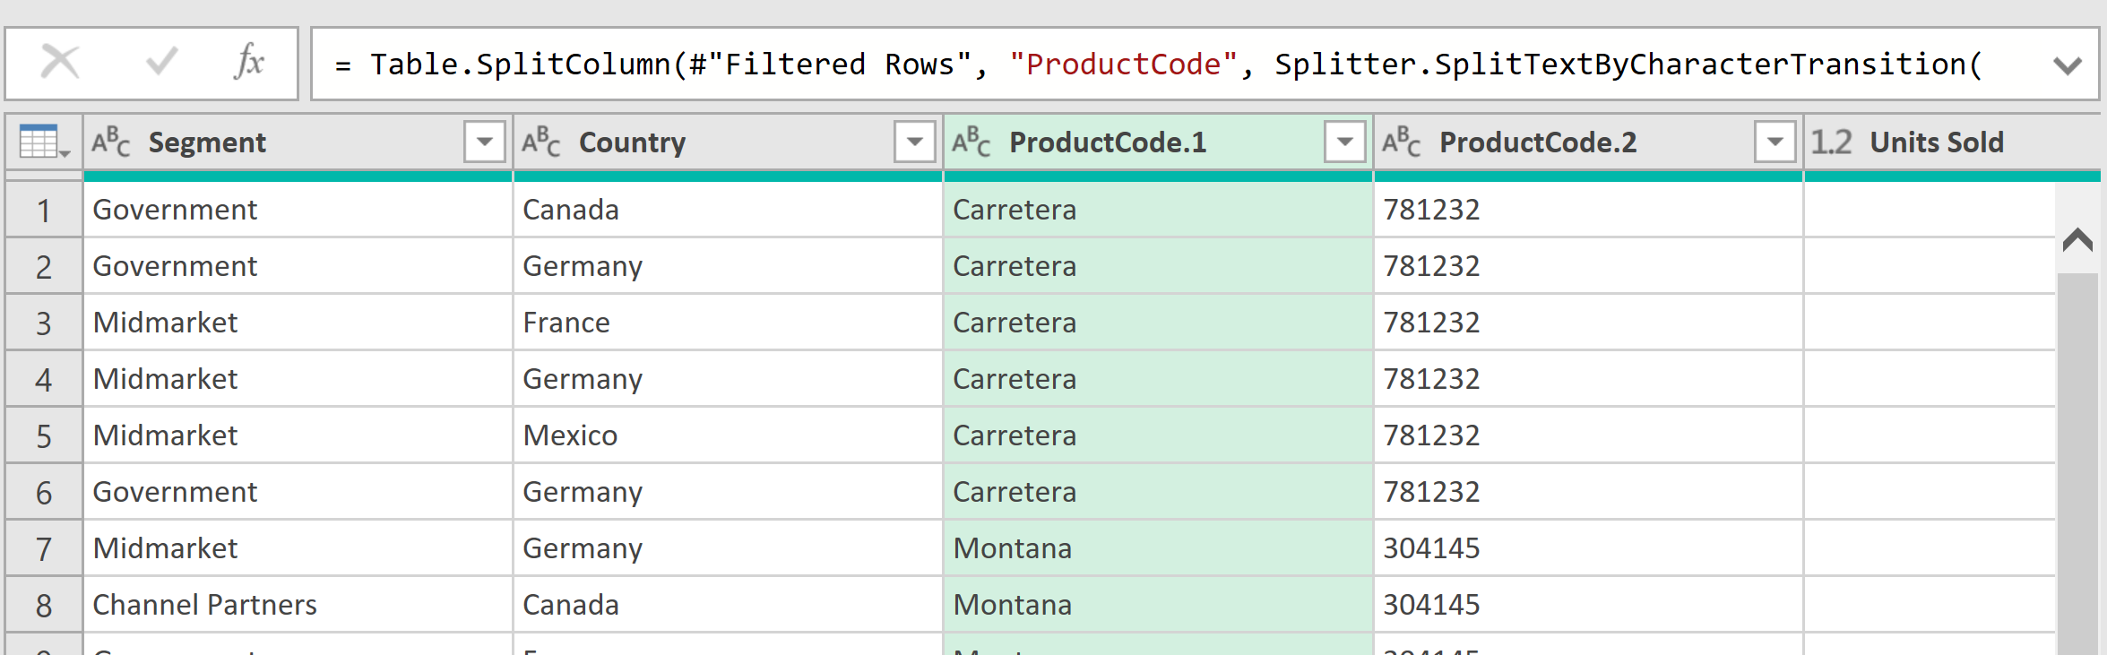

1. Rename the columns as **ProductName** and **ProductID**

# Reshaping Data

## Pivot

1. Select the **Date** column > **Transform > Date > Year**

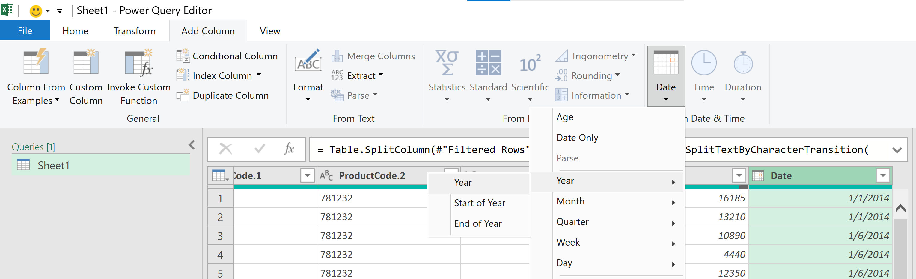

1. Select the **Year** Column > **Transform** > **Pivot Column**.
2. In the Pivot column dialog box, in the Value column list, select **Profit**. By default, Power Query will try to do a sum as the aggregation, but you can select the Advanced option to see other available aggregations.

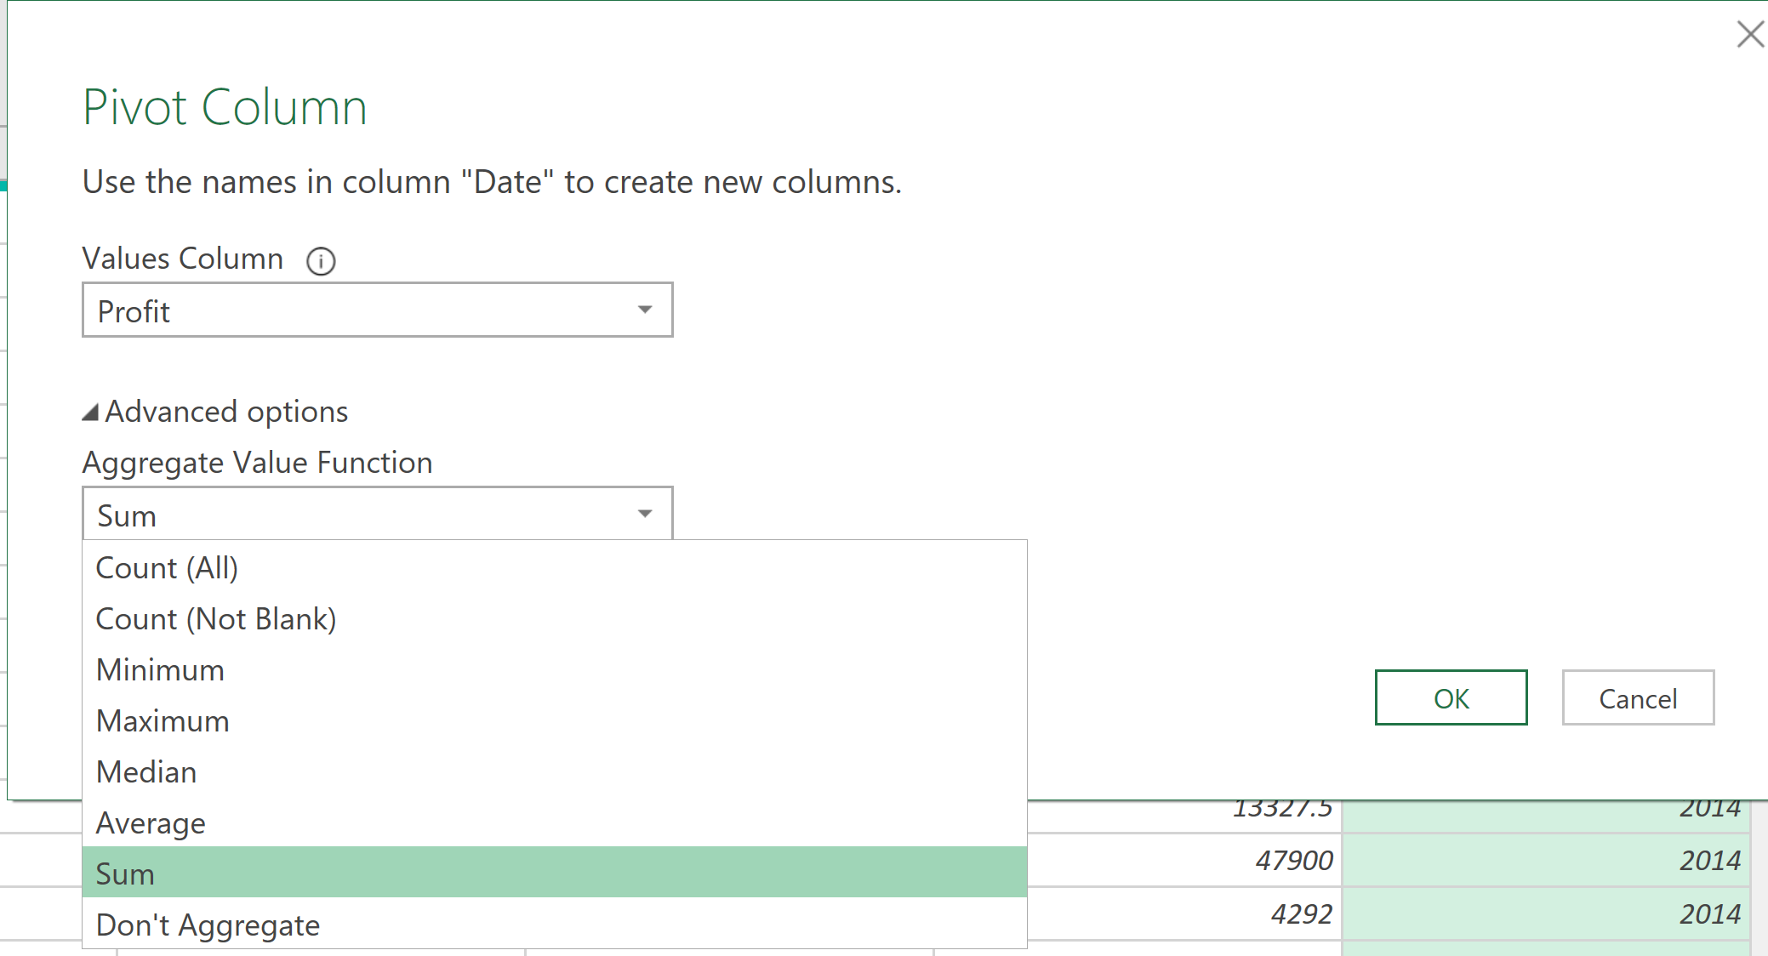

## Unpivot

1. Select columns **2013** and **2014**. To select more than one column contiguously or discontiguously, press Shift+Click or CTRL+Click on each subsequent column.
2. Click **Transform** > **Unpivot Columns**. Rename **Attribute** as **Year** and **Value** as **Profit**.

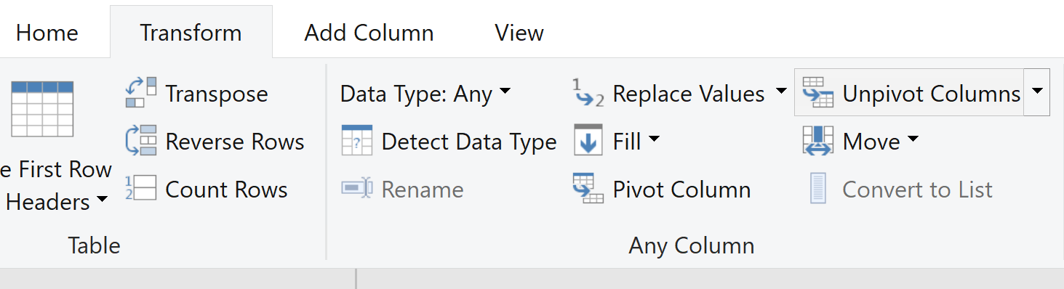

# Aggregating and Filtering Data

## Group Rows of Data

1. Select **Group by** on the **Home** tab.
2. Select the **Advanced** option, so you can select multiple columns to group by.
3. Select the **Country** and **Segment** columns.
4. In the New columns section, create a new column where the name is **Total Profit**, the aggregate operation is **Sum**, and the column used is **Profit**. Hit Ok.

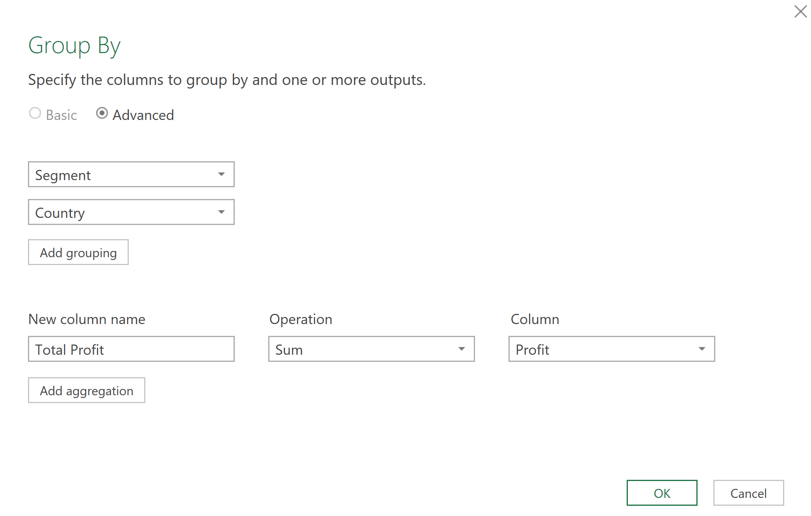

# Importing from a Folder of Files

1. Create a new worksheet.
2. Select **Data** > **Get Data** > **From File** >**From Folder**. The **Browse**dialog box appears. Navigate to the folder “Financial Sample – Folder Import”.

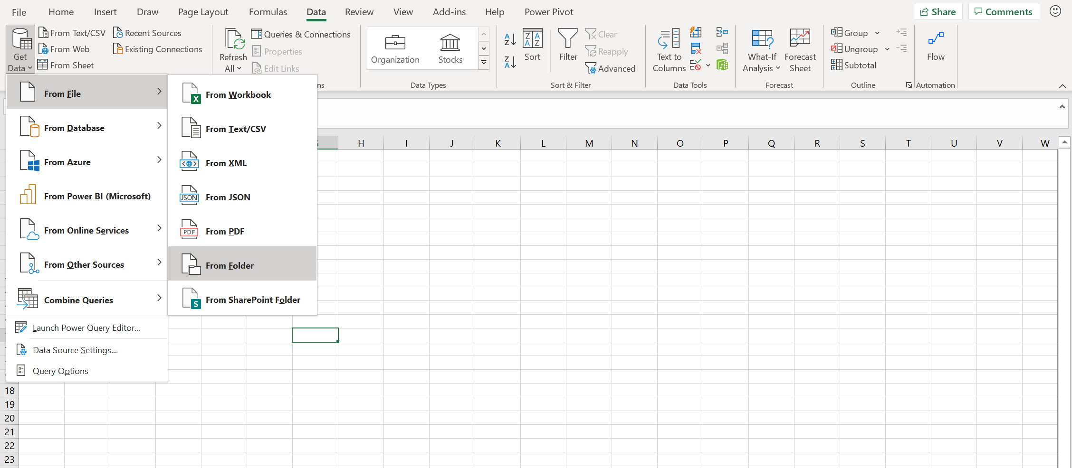

1. A list of the files in the folder appears in the **<Folder path>** dialog box. Verify that all the files you want are listed.

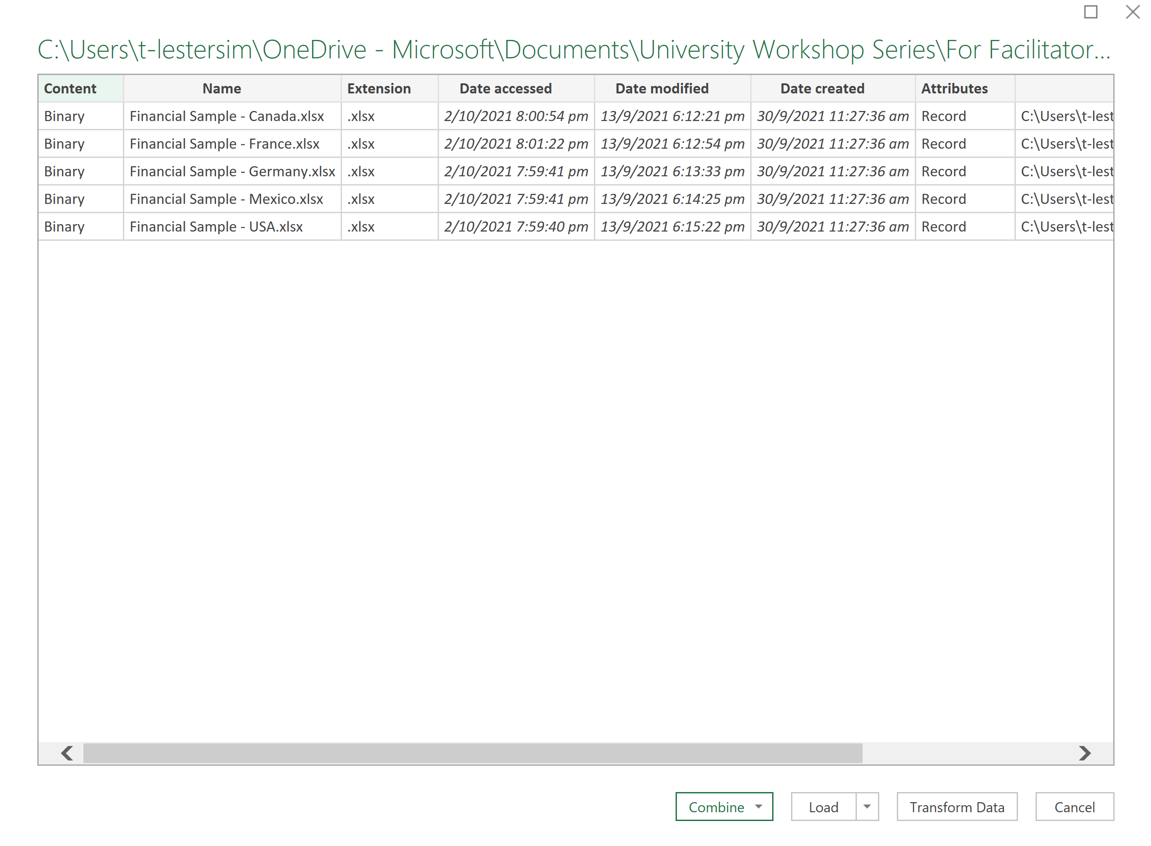

1. Select **Combine**> **Combine & Transform Data**. Select **Table1** as the sample file. Click Ok.

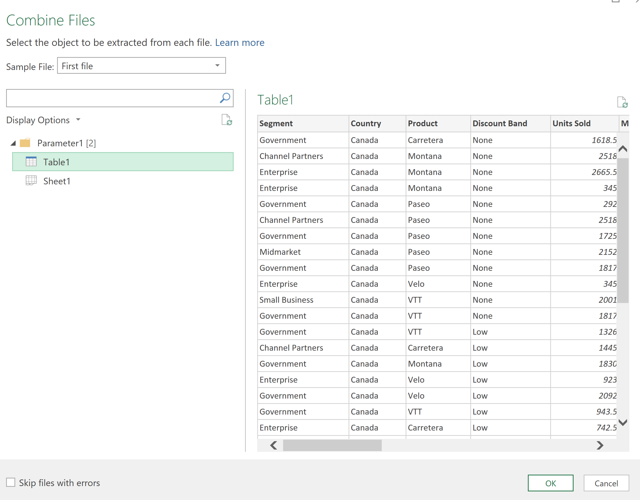

1. You will see several supporting queries are created in the **Queries** pane under the **"Helper Queries"** group.

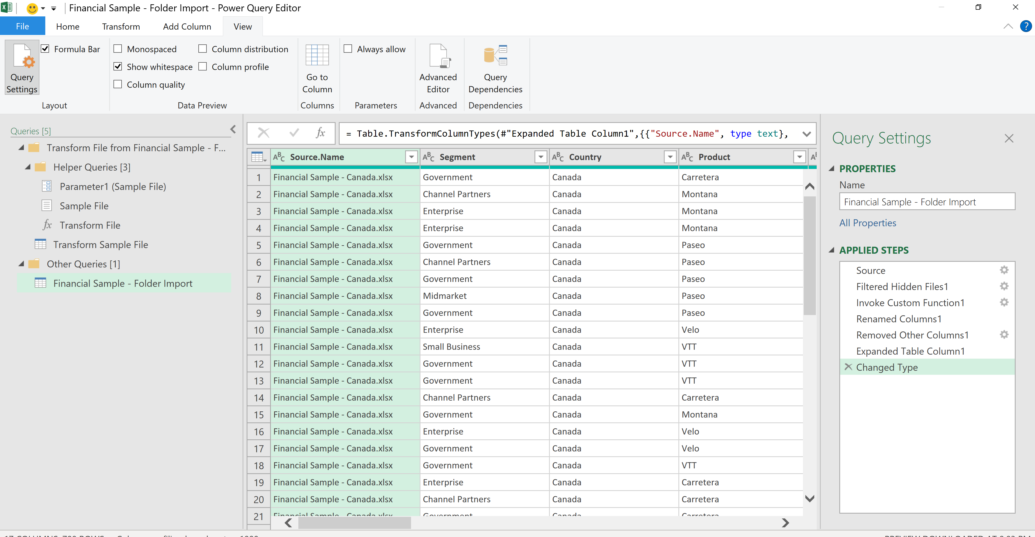

1. Power Query creates a **"Sample File"** query based on the example query.
2. A **"Transform File"** function query uses the "Parameter1" query to specify each file (or binary) as input to the "Sample File" query. This query also creates the Content column containing the file contents and automatically expands the structured Record column to add the column data to the results. The "Transform File" and "Sample File" queries are linked, so that changes to the "Sample File" query are reflected in the "Transform File" query.
3. The query containing the final results is in the "Other queries" group. By default, it is named after the folder you imported the files from.
4. Remove columns that you do not want to output from the “**Financial Sample – Folder Import**” query.
5. Now click **Close & Load.**

# Merging Queries

1. Create a new worksheet.
2. Select **Data > Get Data > From Other Sources > From OData Feed.**

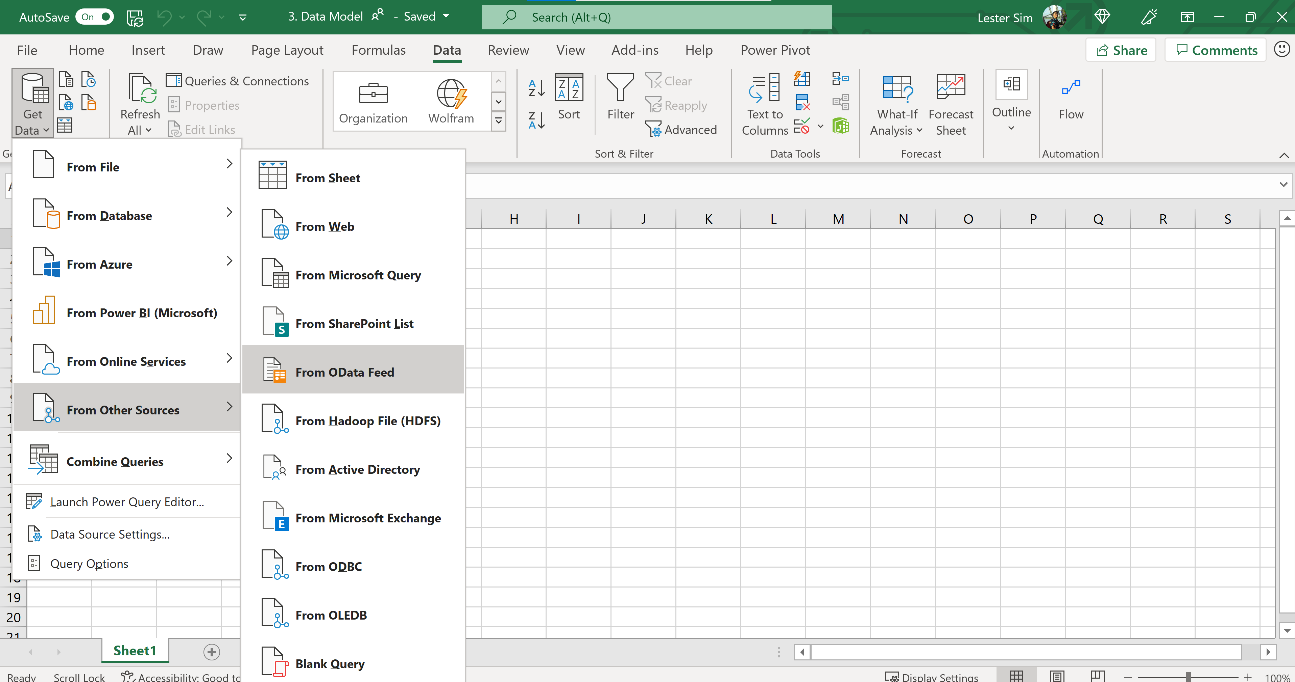

1. In the OData Feed dialog box, enter the URL for the Northwind OData feed: <http://services.odata.org/northwind/northwind.svc/>

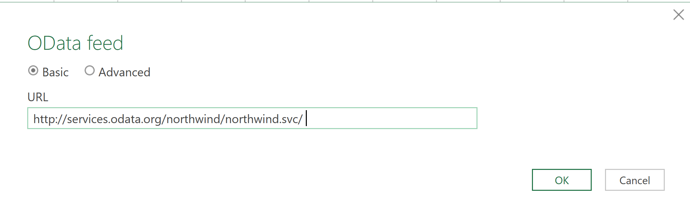

1. Select OK.
2. In the Navigator pane, check **‘Select Multiple Items’**. Select the tables: **Categories**, **Customers, Order_Details, Orders, Products.** Click **Transform Data**.

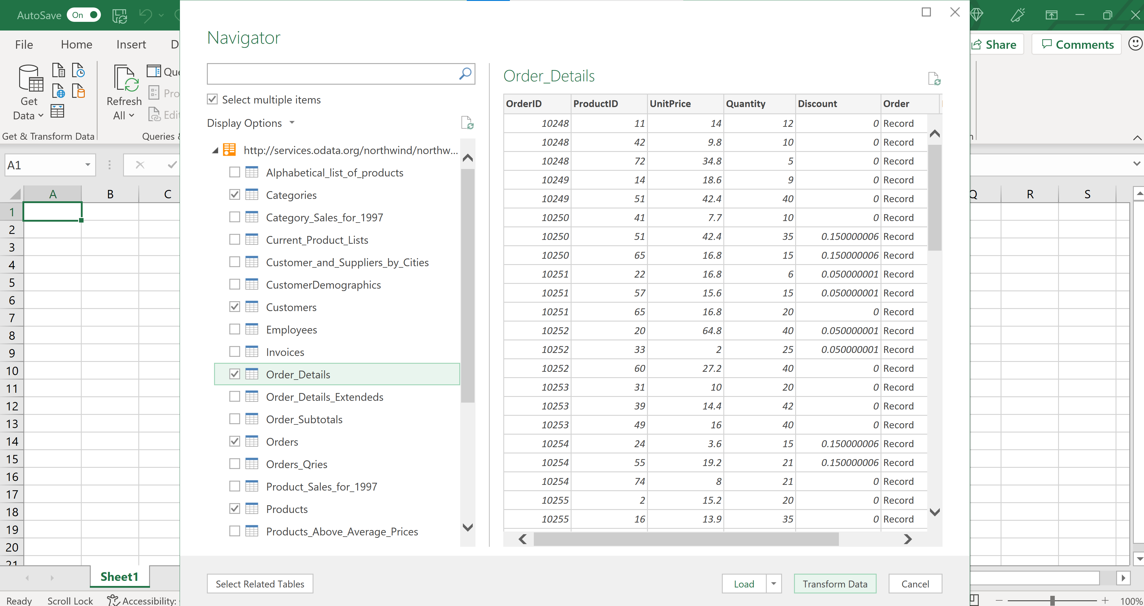

1. Do the following transformations for each of the tables you have just imported
   1. Categories: Select **CategoryID**, **CategoryName**. Remove other columns
   2. Customers: Select **CustomerID, Country.** Remove other columns
   3. Products: Select **ProductID, ProductName, CategoryID**. Remove other columns
   4. Order_Details: Select **OrderID, ProductID, UnitPrice, Quantity**. Remove other columns
      1. Create custom column. New column name is Revenue. Formula as below

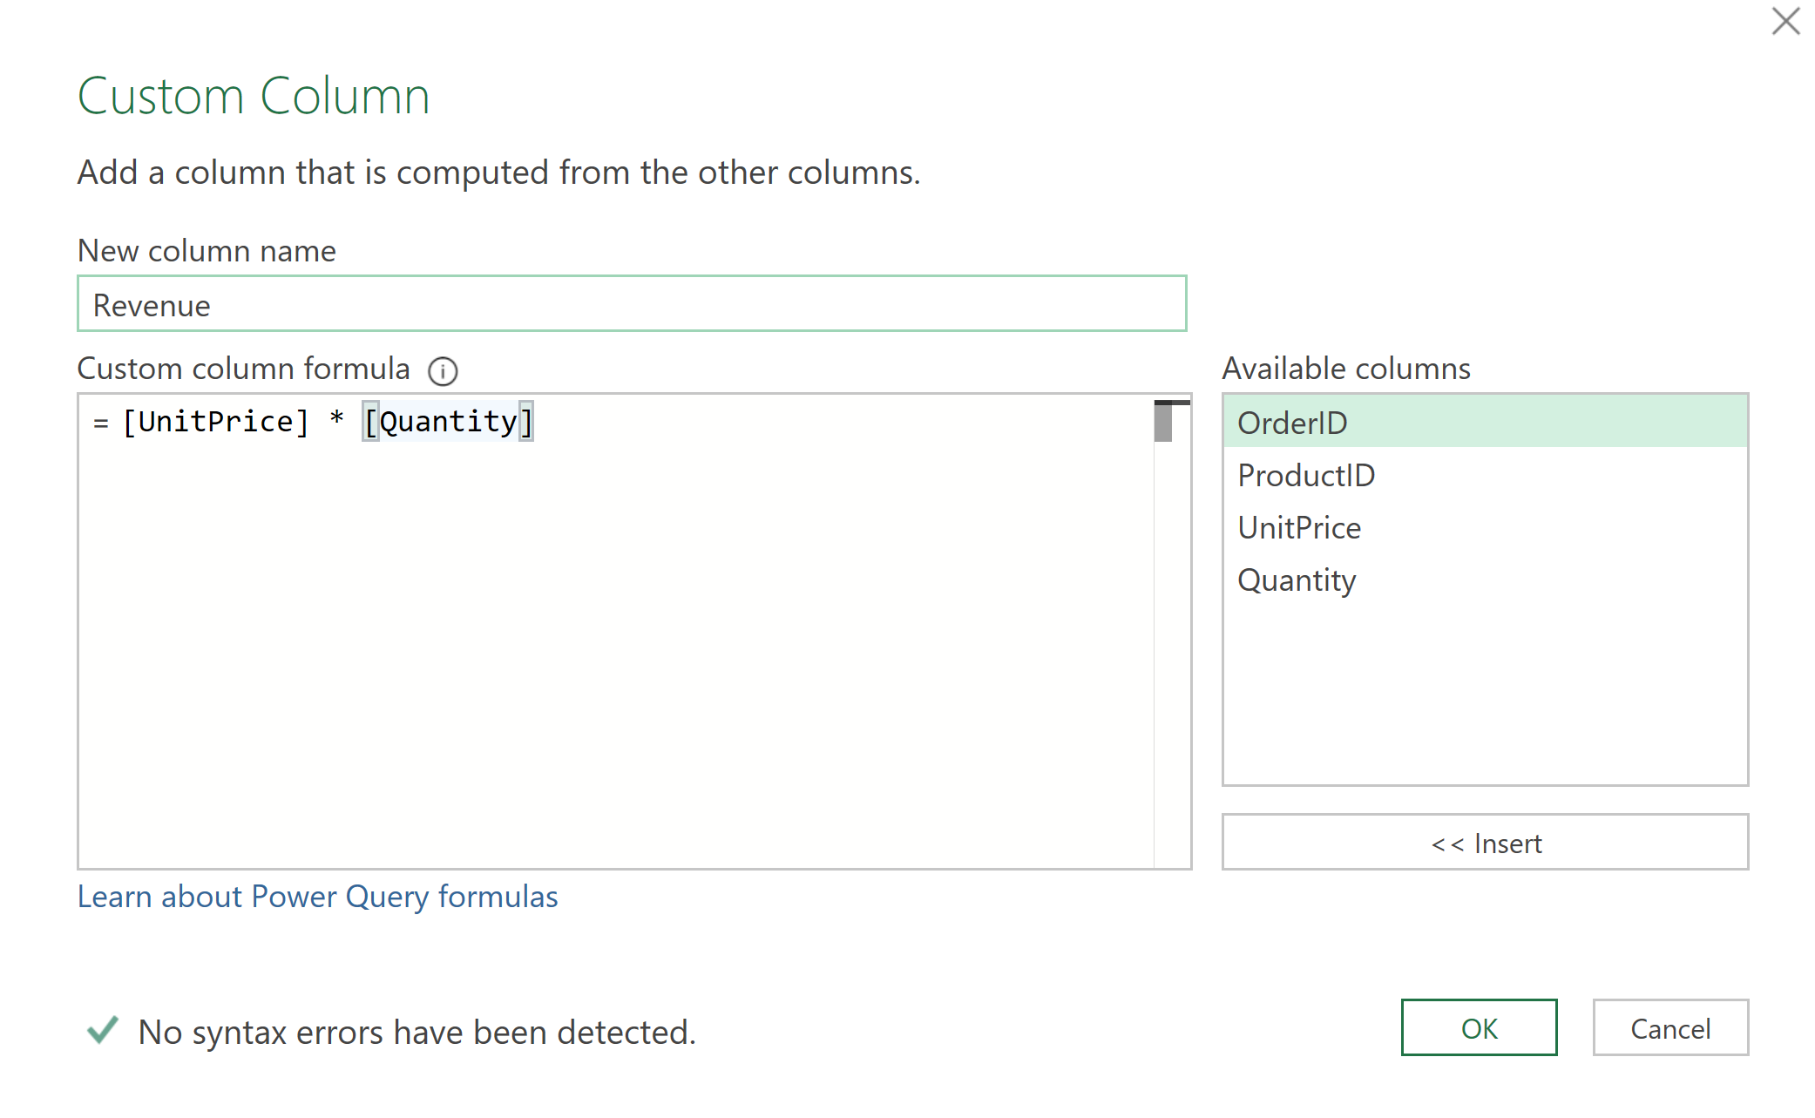

* 1. Orders: Select OrderID, CustomerID, OrderDate. Remove other columns.
     1. Select the OrderDate > Add Column > Date > Year > Year

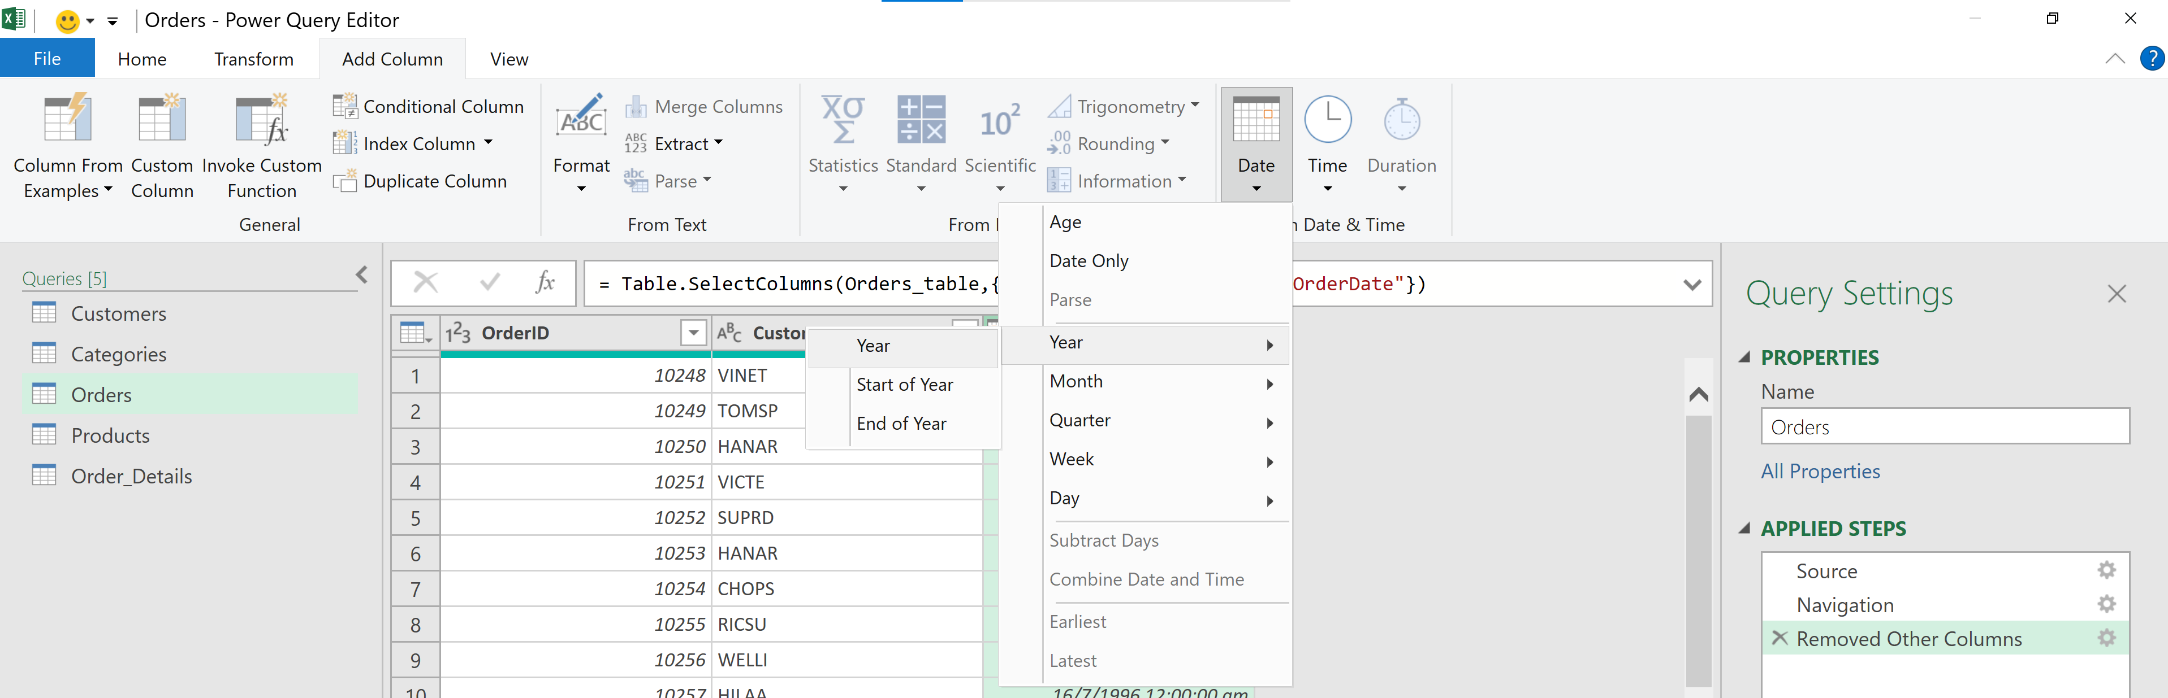

1. Select the Order_Details table. We want to add product names into this table by merging with the Products table. Click on Merge Queries > Select Products as secondary table > Select ProductID column in the primary table > Select ProductID column in the secondary table.

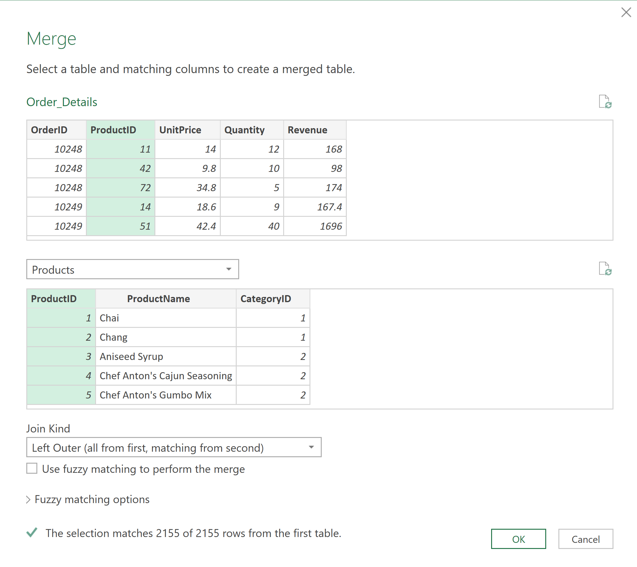

1. Select Left Outer for Join Kind. Click Ok.
2. Expand the Products table and check ProductName and CategoryID only.

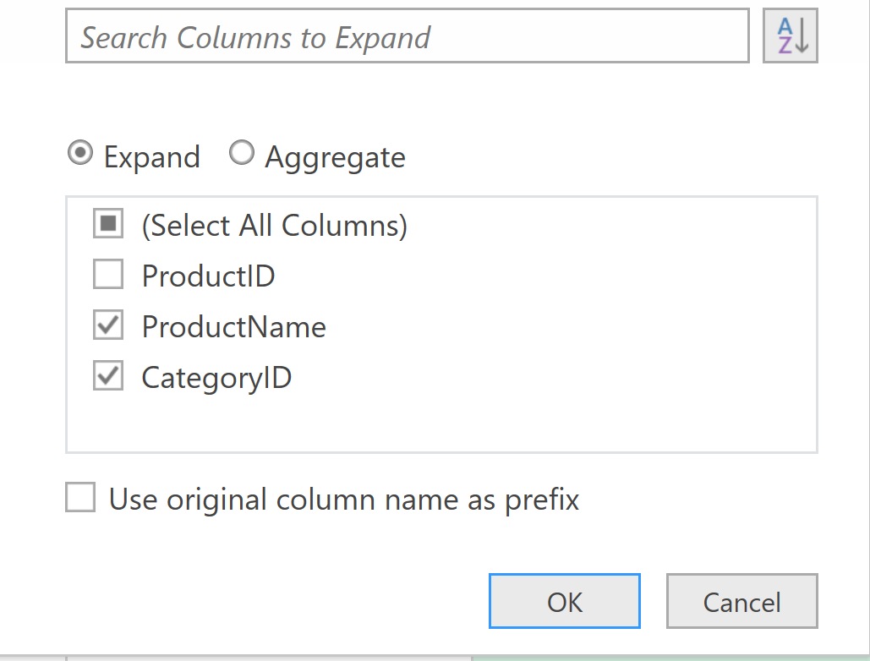

# Power Pivot: Loading to Data Model & Create Relationships

1. Instead of merging datasets, let’s now load the 5 tables (**Customers, Categories, Orders, Products, Order_Details**). Select **Close & Load To**.

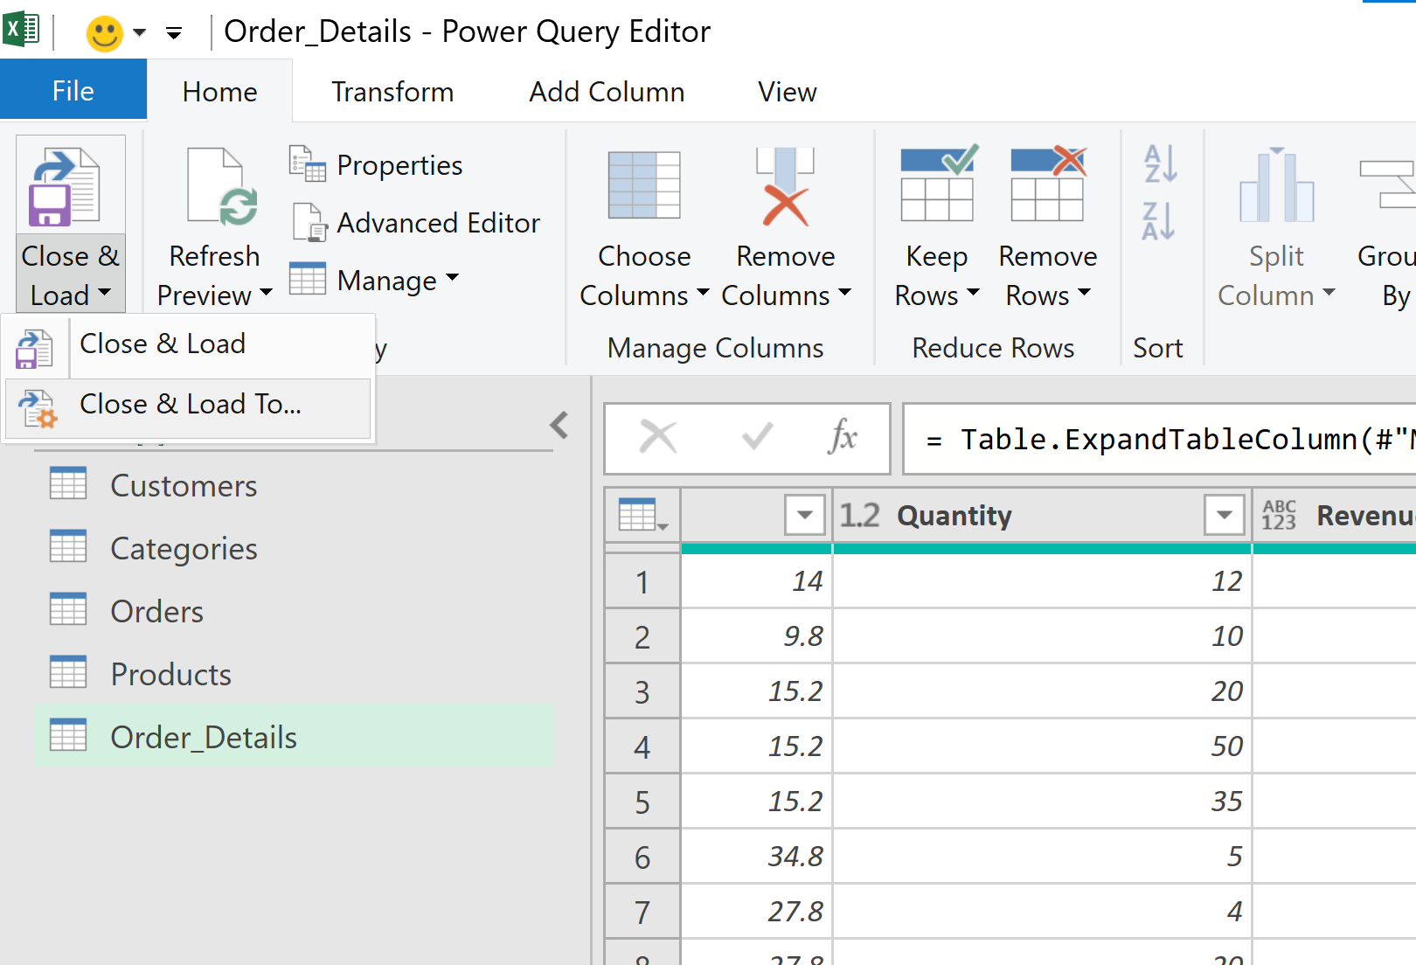

1. An **Import Data** window appears. Check **Only Create Connection** and check **Add this data to the Data Model**. Click Ok.

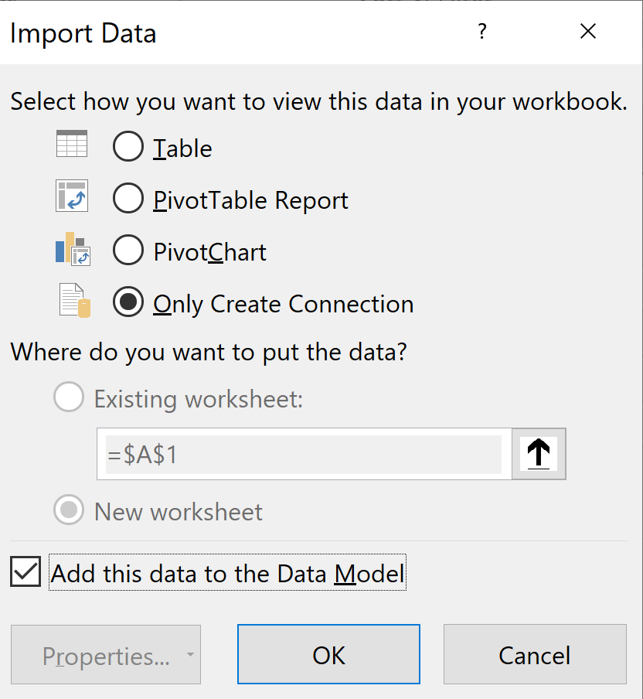

1. Select the **Power Pivot** ribbon > **Manage**

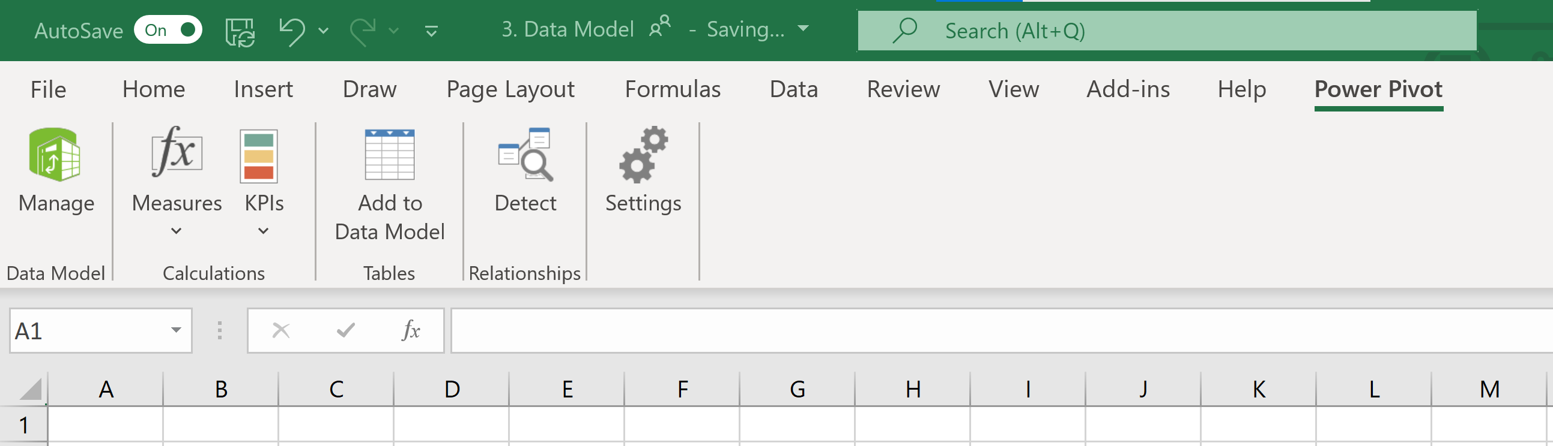

1. A Power Pivot window will appear containing the different tables as tabs.
2. We will now create relationships between tables. Select **Diagram View** at the top right of the window.

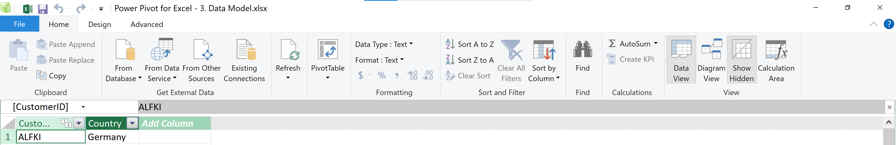

1. Relationships were automatically detected between tables and established for us.

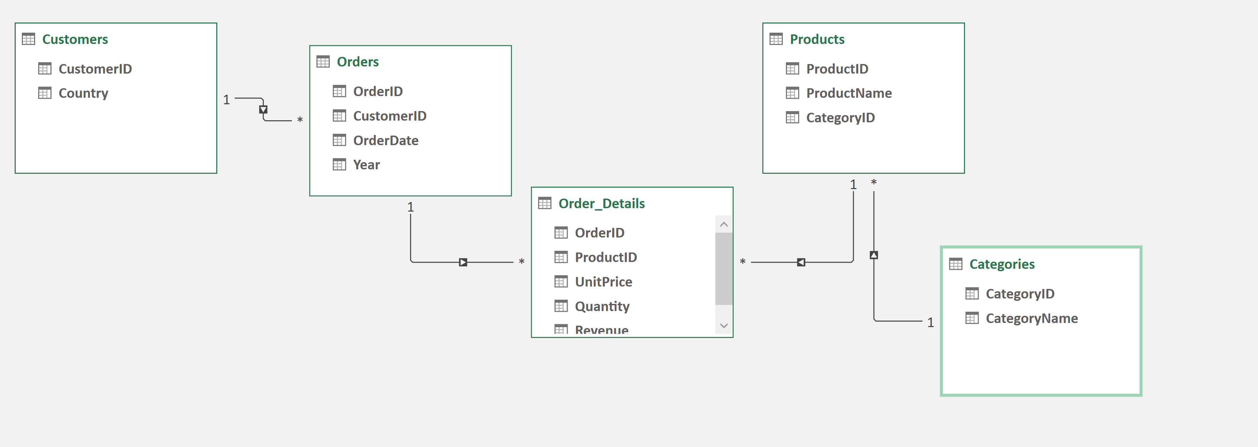

1. Delete the relationship between **Customers** and **Orders** table. Right click on the relationship line > Delete. We will re-create the relationship next.
2. To create a relationship, click on CustomerID from Customers table and drag to CustomerID from Orders table. Excel will automatically detect a 1:Many relationship between these 2 tables.

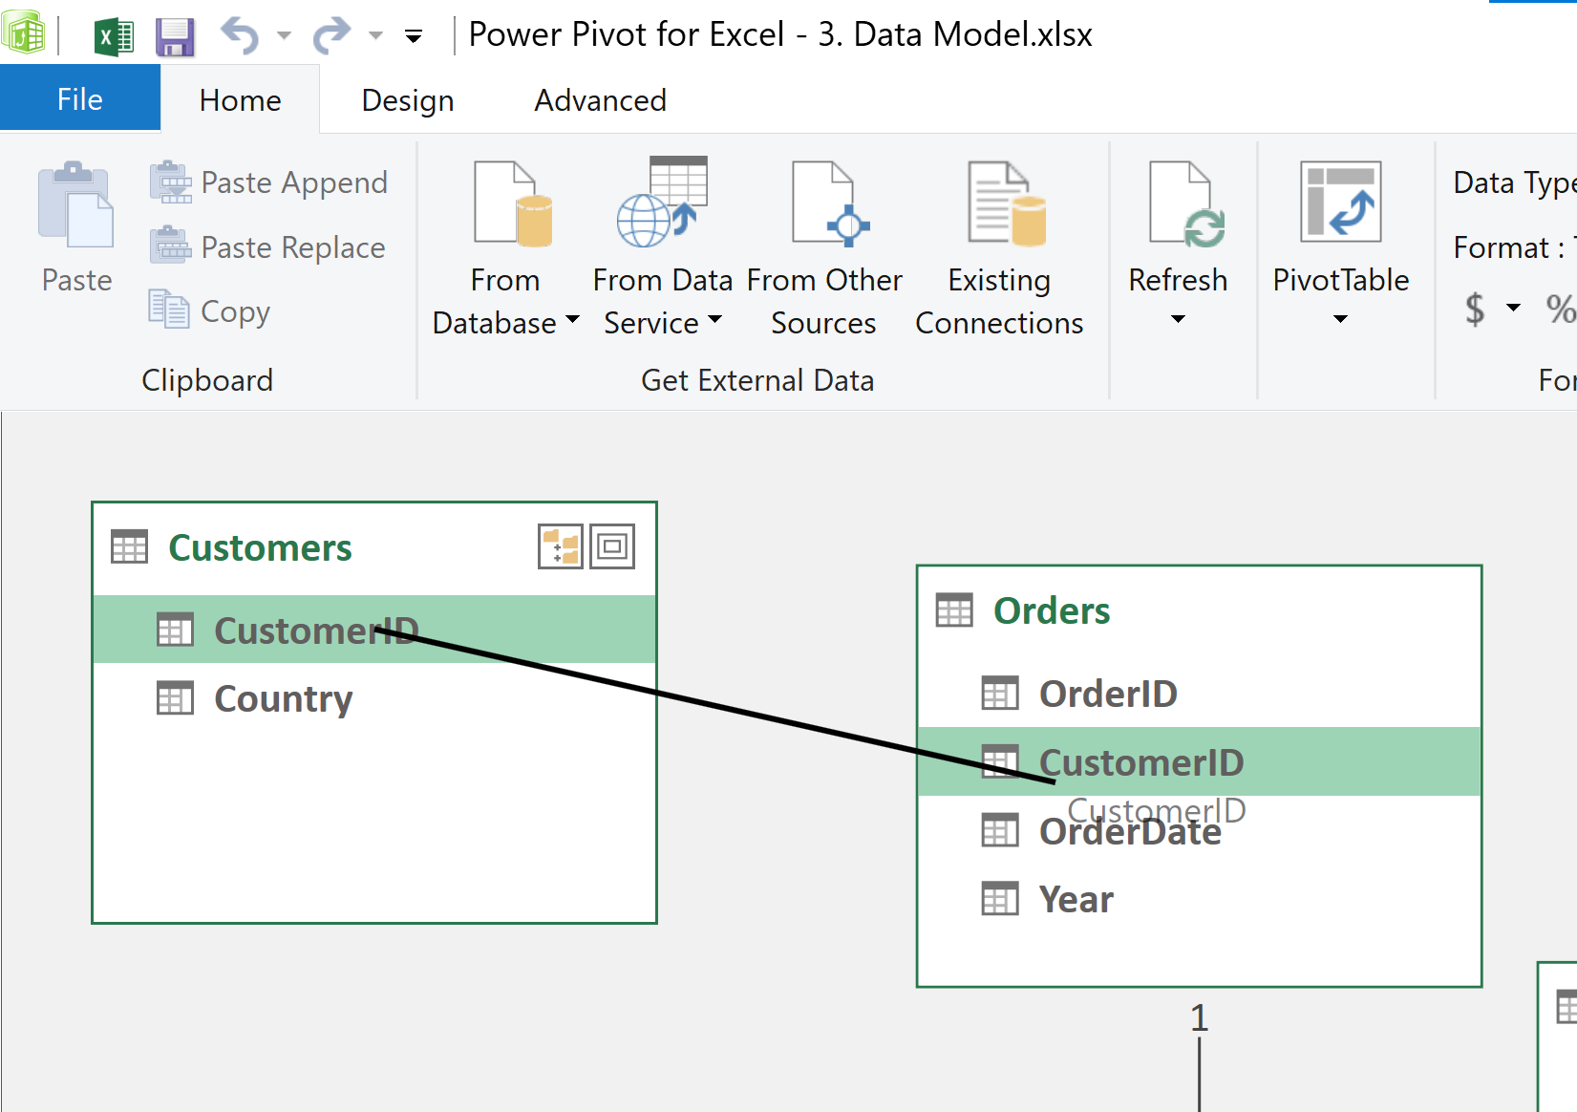

# Power Pivot: Creating PivotTables from Data Model

1. Close the Power Pivot window. On Excel click **Insert** > **Pivot Table** > From **Data Model**

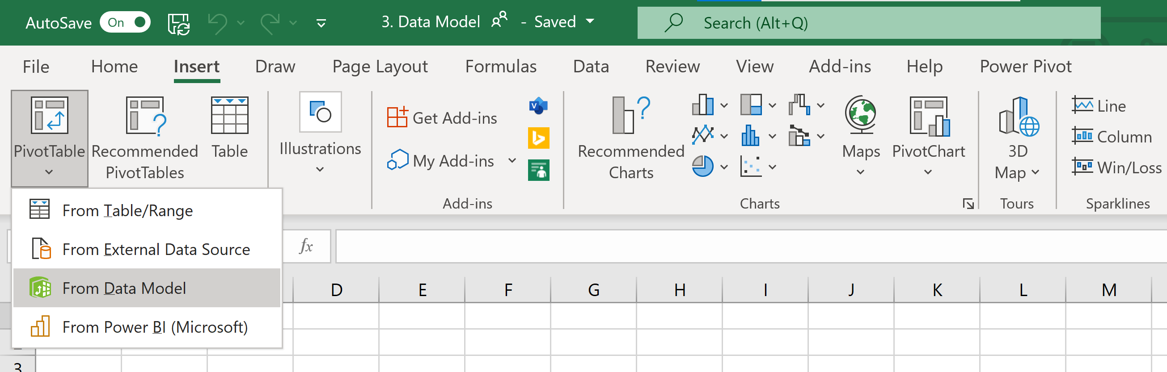

1. The PivotTable Fields now show the different tables being loaded.
2. Let’s create a PivotTable showing how the revenue for different category of products have changed over the years.
   1. Drag **CategoryName** to Rows, **Year** to Columns, **Revenue** to Values.
3. Let’s create a PivotTable showing where our customers are spending the most in a specific year.
   1. Drag **Year** to Filter, **Country** to Rows, **Revenue** to Values
   2. Sort descending by Revenue
4. Let’s create a PivotTable showing how the quantity demanded for each product has change over the years.
   1. Drag **ProductName** to Rows, **Year** to Columns, **Quantity** to Values.

# References

<https://support.microsoft.com/en-us/office/import-data-from-external-data-sources-power-query-be4330b3-5356-486c-a168-b68e9e616f5a>

<https://support.microsoft.com/en-us/office/import-data-from-a-folder-with-multiple-files-power-query-94b8023c-2e66-4f6b-8c78-6a00041c90e4>

<https://support.microsoft.com/en-us/office/merge-queries-power-query-fd157620-5470-4c0f-b132-7ca2616d17f9>

<https://support.microsoft.com/en-us/office/create-a-fuzzy-match-power-query-ffdd5082-c0c8-4c8e-a794-bd3962b90649>

<https://docs.microsoft.com/en-us/power-query/pivot-columns>

<https://support.microsoft.com/en-us/office/unpivot-columns-power-query-0f7bad4b-9ea1-49c1-9d95-f588221c7098>